Online Sales Analysis

​Project Overview and Objective
Overview:
This project involves cleaning, transforming, and analysing raw data using Excel and creating an interactive Power BI dashboard to derive meaningful business insights.
Object:
The main objective is to demonstrate data pre-processing techniques using Excel and an interactive Power BI dashboard visualization to make informed decisions.

Data Sources
  - Source Description and Timeline: https://www.zoho.com/analytics/sample-data-generator.html
  - Domain: sales

Problem Statement;
∉ To analyse sales performance across products to identify high performing areas and profit trends.
∉ To study crop production patterns across online shopping sales.
∉ To understand customer purchasing behaviour to enhance marketing and retention strategies.

Attribute (Column /Features) Details:

Product Details

S.No | Attribute Name | Description | Data Type

1 | Transaction _ID | Unique ID for each transaction | Text
2 | Product _ ID | Unique ID for each product | Text
3 | Product_category | Category of the product | Categorical
4 | Product_name | Name of the product | Text
5 | Quantity | Number of units purchased | Numerical
6 | Unit_Price | Price of one product unit | Numerical
7 | Total_Amount | Total sales amount | Numerical

Customer Details

S.No | Attribute Name | Description | Data Type
1 | Customer_ID | Unique ID for each customer | Text
2 | Product_ID | ID of the purchased product | Text
3 | Custmer_name | Name of the customer | Text
4 | Custmer_Email | Email address of the customer | Text

Transaction Details

S.No | Attribute Name | Description | Data Type

1 | Transaction_ID | Unique ID for each transaction | Text
2 | Product_ID | ID of the purchased product | Text
3 | Transaction_Date | Date and time of the transaction | Date/Time
4 | Payment_Status | Status of the payment | Categorical

Tools & Technologies
  - Excel: Data cleaning, transformation, and Pivot Tables.
  - Power BI: Data modelling, DAX calculations, visualization, and interactive dashboard.

Data Pre-Processing (Excel / Power Query)

Tasks Performed:
  - Data Cleaning & Transformation: create separate id for product , customer , make separate sheets using id.
  - Filtering & Sorting: Organized data to focus on relevant records.
7. Data Modelling and DAX (Power BI)
- Data Model: Established relationships between tables, defined cardinality, and created lookup tables where necessary.
SCREENSHOT OF DATA MODELLING
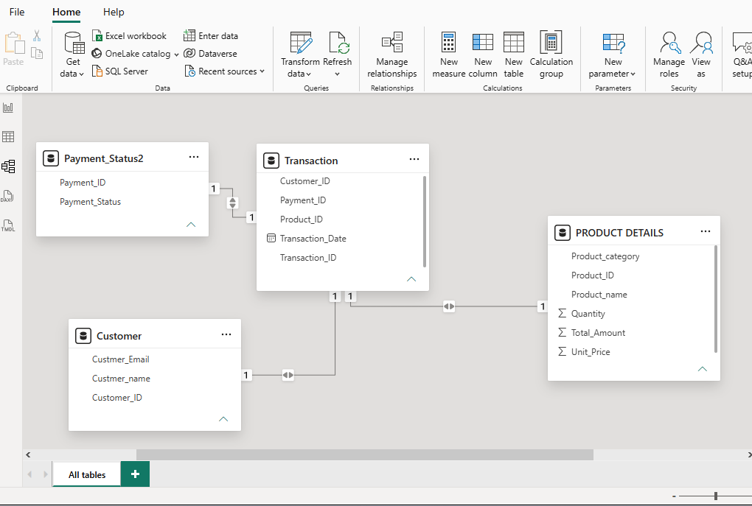

DAX Measures:
Implemented DAX formulas for key metrics, such as total sales, AVG sales , high sales , min sales and total unit.
FORMULA:
- Total sales formula: total_ sales = SUM('PRODUCT DETAILS'[Total_ Amount])
- Average sales : average _sales = AVERAGE('PRODUCT DETAILS'[Total _ Amount])
- High sales : HIGH_SALES = CALCULATE(SUM('PRODUCT DETAILS'[Total_ Amount]),FILTER('PRODUCT DETAILS','PRODUCT DETAILS'[Total _Amount]>500))
- Min sales: MIN_SALES = MIN('PRODUCT DETAILS'[Total_ Amount])
- Total unit sales: TOTAL_UNIT_SALES = COUNT('PRODUCT DETAILS'[Quantity])

- Analysis and Visualizations (Power BI):
- Multiple Visualizations based on problem statement: Bar charts, line charts, pie charts, cards, and tables to communicate insights.
- Make your Report interactive Layout using Drill-down, Filters and slicers.
- Bookmarks, Clear Titles for each visuals & Labels is must.
- Create a consolidated Report /Dashboard.
SCREENSHOT OF DASHBOARD /REPORT
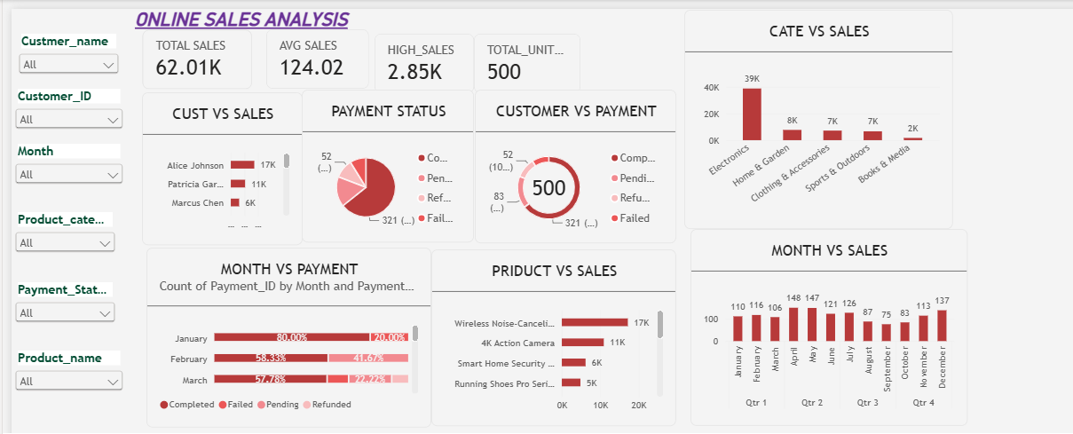
9. Insights & Conclusions
- Key Findings:
- The dashboard helps identify total sales and average sales.
- Customer-wise analysis shows which customers contribute more to sales.
- Category-wise analysis helps identify popular product categories.
- Product-wise analysis helps compare product sales performance.
- Payment status analysis helps understand successful and pending payments.
- Monthly analysis helps identify sales trends over time.

- Provide the analysis insights:
1. Descriptive Analysis
- Analyzed total sales, average sales, minimum sales, and maximum sales.
- Identified sales performance by customers, products, and categories.
2. Diagnostic Analysis
- Compared sales across different customers and product categories.
- Analyzed payment status to understand payment-related differences.
- Examined monthly sales variations to understand changes in performance.
3. Predictive Analysis
- Used historical monthly sales trends to understand possible future sales patterns.
- Sales forecasting can help estimate future sales performance.
- Identified potential changes in sales based on previous trends.
4. Prescriptive Analysis
- Focus on products and categories with lower sales to improve performance.
- Improve customer engagement to increase sales.
- Follow up on pending payments.
- Use monthly sales trends to plan future business strategies.

10. Conclusions:
The Product Sales Analysis project helps understand overall sales performance using Power BI. It provides useful insights into customer behaviour, product categories, monthly sales trends, and payment status. Interactive dashboards and visualizations make it easier to identify sales patterns and business performance. This analysis helps businesses make better decisions, improve sales, and plan future strategies.

